Python Tech Challenge

Challenge: Create a Dockerized Python Web Application that shows graphs of NBA player statistics.

Acceptance Criteria:

1. The application should be deployable in any host that has a Docker Engine or equivalent
2. Deployment should be done by executing a single **docker-compose** command
3. The source data of the player statistics is a CSV file that will be provided herein
4. The application should be reachable by typing a URI on a standard browser, i.e.

<http://ip_address_or_domain:port/nbastats>

1. The home page should show a list of statistics that can be displayed as below:

1. On selection of the desired parameters, output would be a page showing the appropriate graph generated dynamically from the provided inputs, as in the sample below:

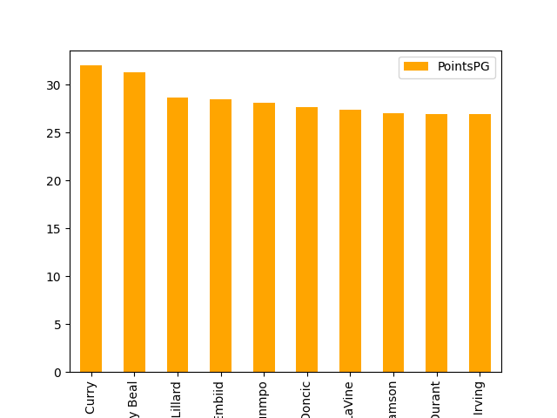 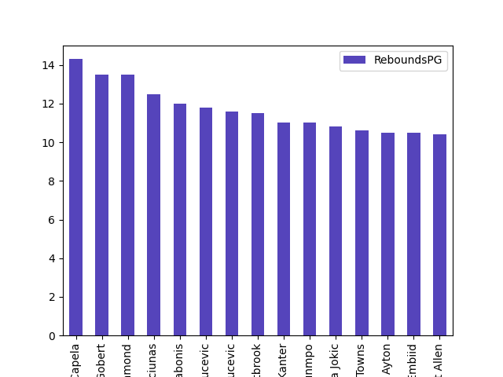

1. Acceptable web frameworks include Flask, FastAPI, Django and other similar well-known Python products. Other libraries that can be used include Pandas, Matplotlib and similar
2. Docker image that MUST be for the python app is **python 3.9.5-slim-buster**
3. Final artifact should be a zip file containing application codes, relevant Dockerfiles (if needed) and the deployment docker-compose.yml file
4. After submission, product will be deployed in a Macbook Pro or Windows laptop with Docker Engine by executing a single **docker-compose up -d** on the folder containing the docker-compose.yml file